Photo credit: Jack Robinson

From intimate clubs to Wembley glory with Sam Ryder and Sennheiser Spectera
Monitor engineer Jamie Hickey puts revolutionary wideband wireless ecosystem through its paces across venues of every size

Marlow, UK, December 2025 – When British singer-songwriter Sam Ryder embarked on his Road to Wembley tour in October 2025, the journey took him from the intimate corners of small clubs to the iconic expanse of Wembley Arena – a lifelong dream fulfilled. For monitor engineer Jamie Hickey, the tour presented a unique opportunity to test Sennheiser’s Spectera wideband wireless ecosystem in the most demanding and diverse environments imaginable. The result? A resounding validation of the system’s versatility, reliability, and sonic excellence across every venue on the tour.

For his Road to Wembley tour, Sam Ryder had selected venues that played a special role in his early career, culminating in a performance at Wembley on November 6 (Photo credit: Jenny Hodge) | 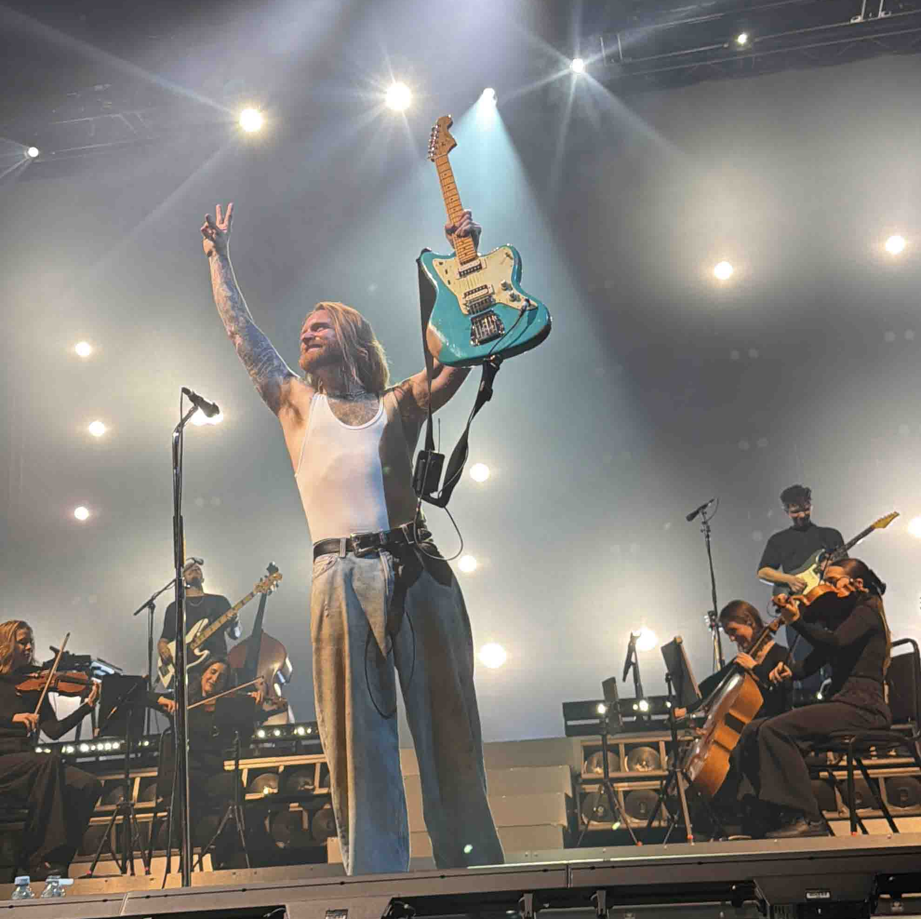

From Eurovision to Wembley
Sam Ryder captured hearts across Europe with his second-place finish at Eurovision 2022, bringing the UK its best result in decades. Since then, the TikTok sensation-turned-mainstream success has continued to build a devoted following with his powerful vocals and authentic stage presence. Road to Wembley coincided with the release of his second album, ‘Heartland’, released on 17 October 2025. The tour was designed as a series of intimate shows leading up to a much larger performance at OVO Arena Wembley on 6 November.

Ryder hand-picked venues with sentimental value from his early career, including The Cavern Club in Liverpool, Cavern in Exeter, Clwb Ifor Bach in Cardiff, and King Tut’s Wah Wah Hut in Glasgow. Every venue hosted both a matinee and an evening show, creating an intensive schedule.

A natural progression
Jamie Hickey, one half of the duo behind Production & Touring Ltd, brought 20 years of monitor engineering experience to his first tour with Sam Ryder. “It’s something I’ve always loved,” says Hickey of his job. “The thing I really enjoy is the challenge of getting into somebody’s head space and trying to understand what they want.”

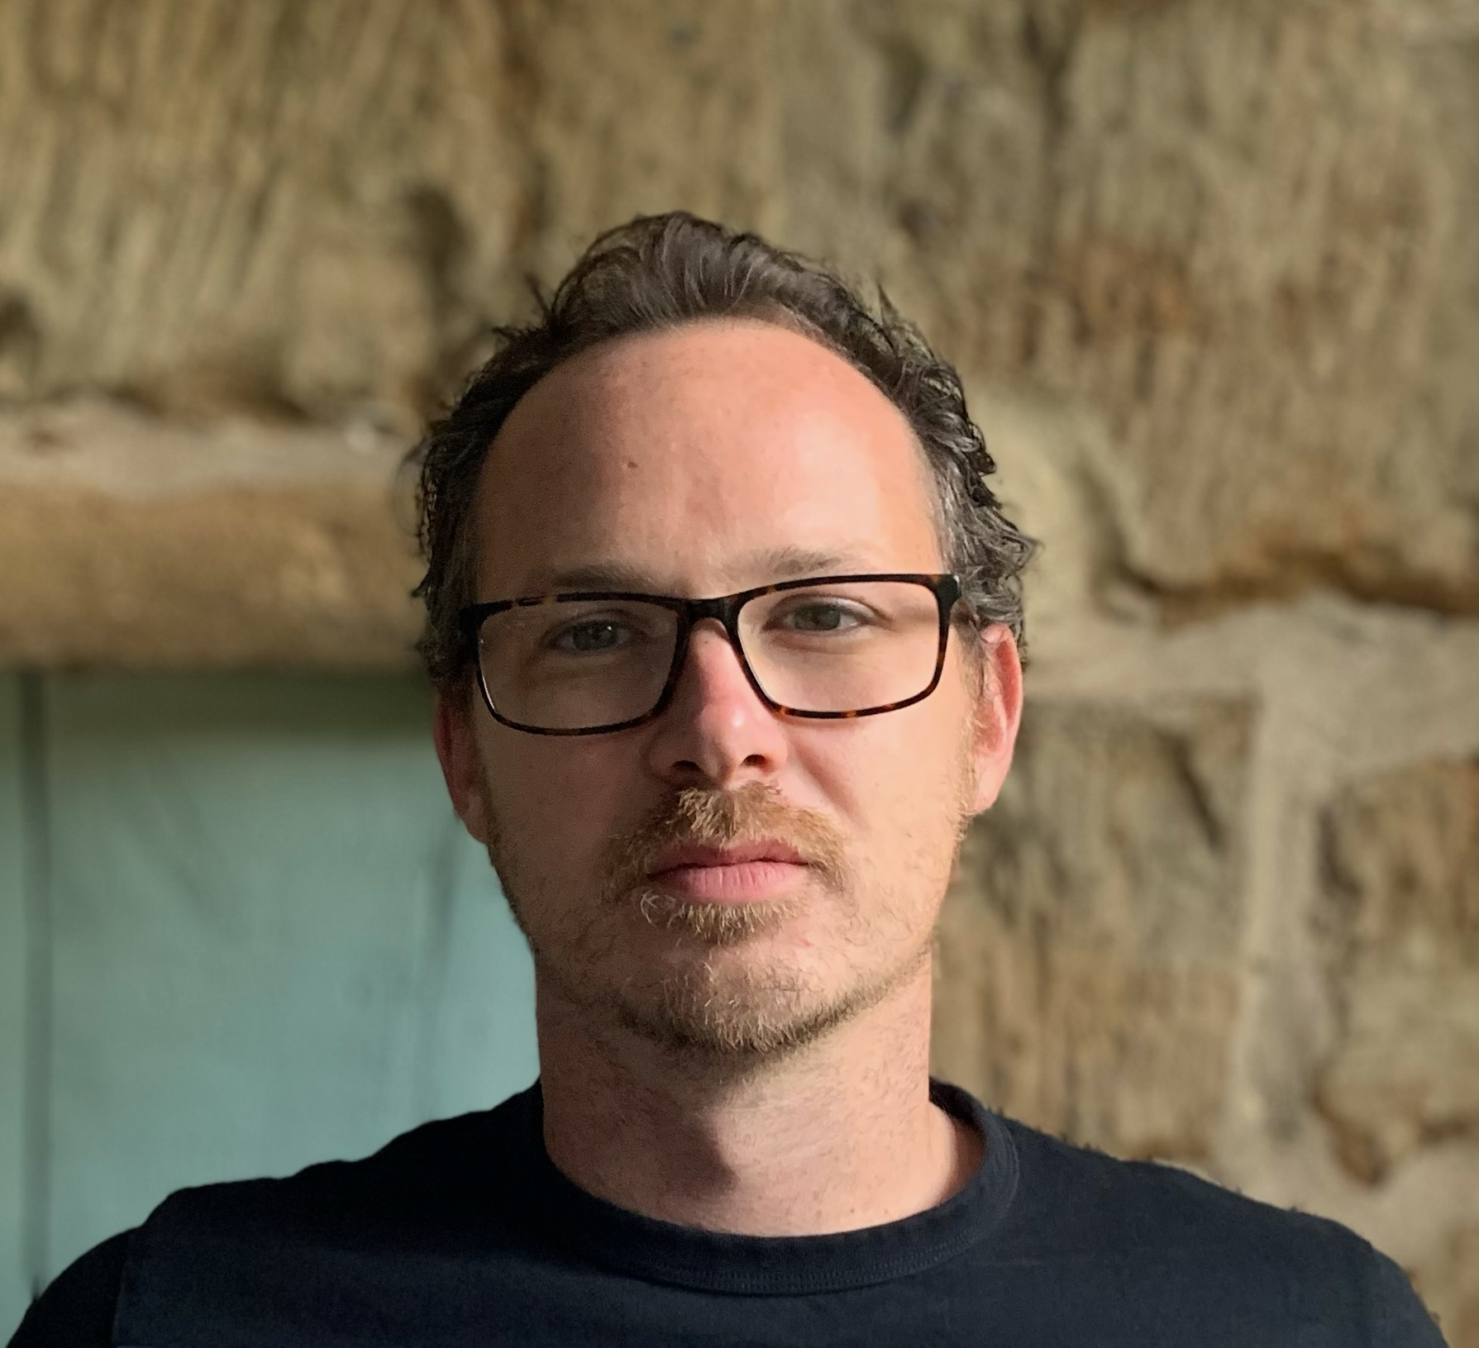 | Jamie Hickey, one half of Production & Touring Ltd, brought 20 years of monitor engineering experience to his first tour with Sam Ryder

Hickey’s business partner, Mike Taylor, who served as Production Manager, led the charge to have Spectera go out on the Road to Wembley tour.

As a long-time Sennheiser user with experience on the 2000 series IEM and evolution G4 wireless systems, Hickey had been eagerly anticipating the arrival of Spectera. “It was a natural progression to move to Spectera as soon as it was available,” he explains. “I arranged with Peter Craig [Sennheiser Relations Management] to be part of the Spectera Pioneer Program and get it out there and start using it. Not just in the obvious settings — the big arena shows — but to find out what it’s like under the spotlights of a small venue. And this Sam Ryder tour was an ideal scenario for that, because it culminated in a show at Wembley. But the run up to it was lots of small little gigs, 300 capacity venues, and we had all the same equipment for those shows that we had for the arena show.”

For Hickey, the technical advantages of the system were clear from the start. “The first thing you notice when using Spectera is the complete lack of background hiss; the traditional noise floor is a thing of the past,” he explains. “As soon as you start passing audio through the system, you can’t help but be impressed by the frequency response and stereo image. There’s so much space. Reverbs, keyboards, stereo guitar patches all come alive in a way that was previously impossible in live monitoring. It’s true stereo in IEMs for the first time, and it sounds really, really good.”

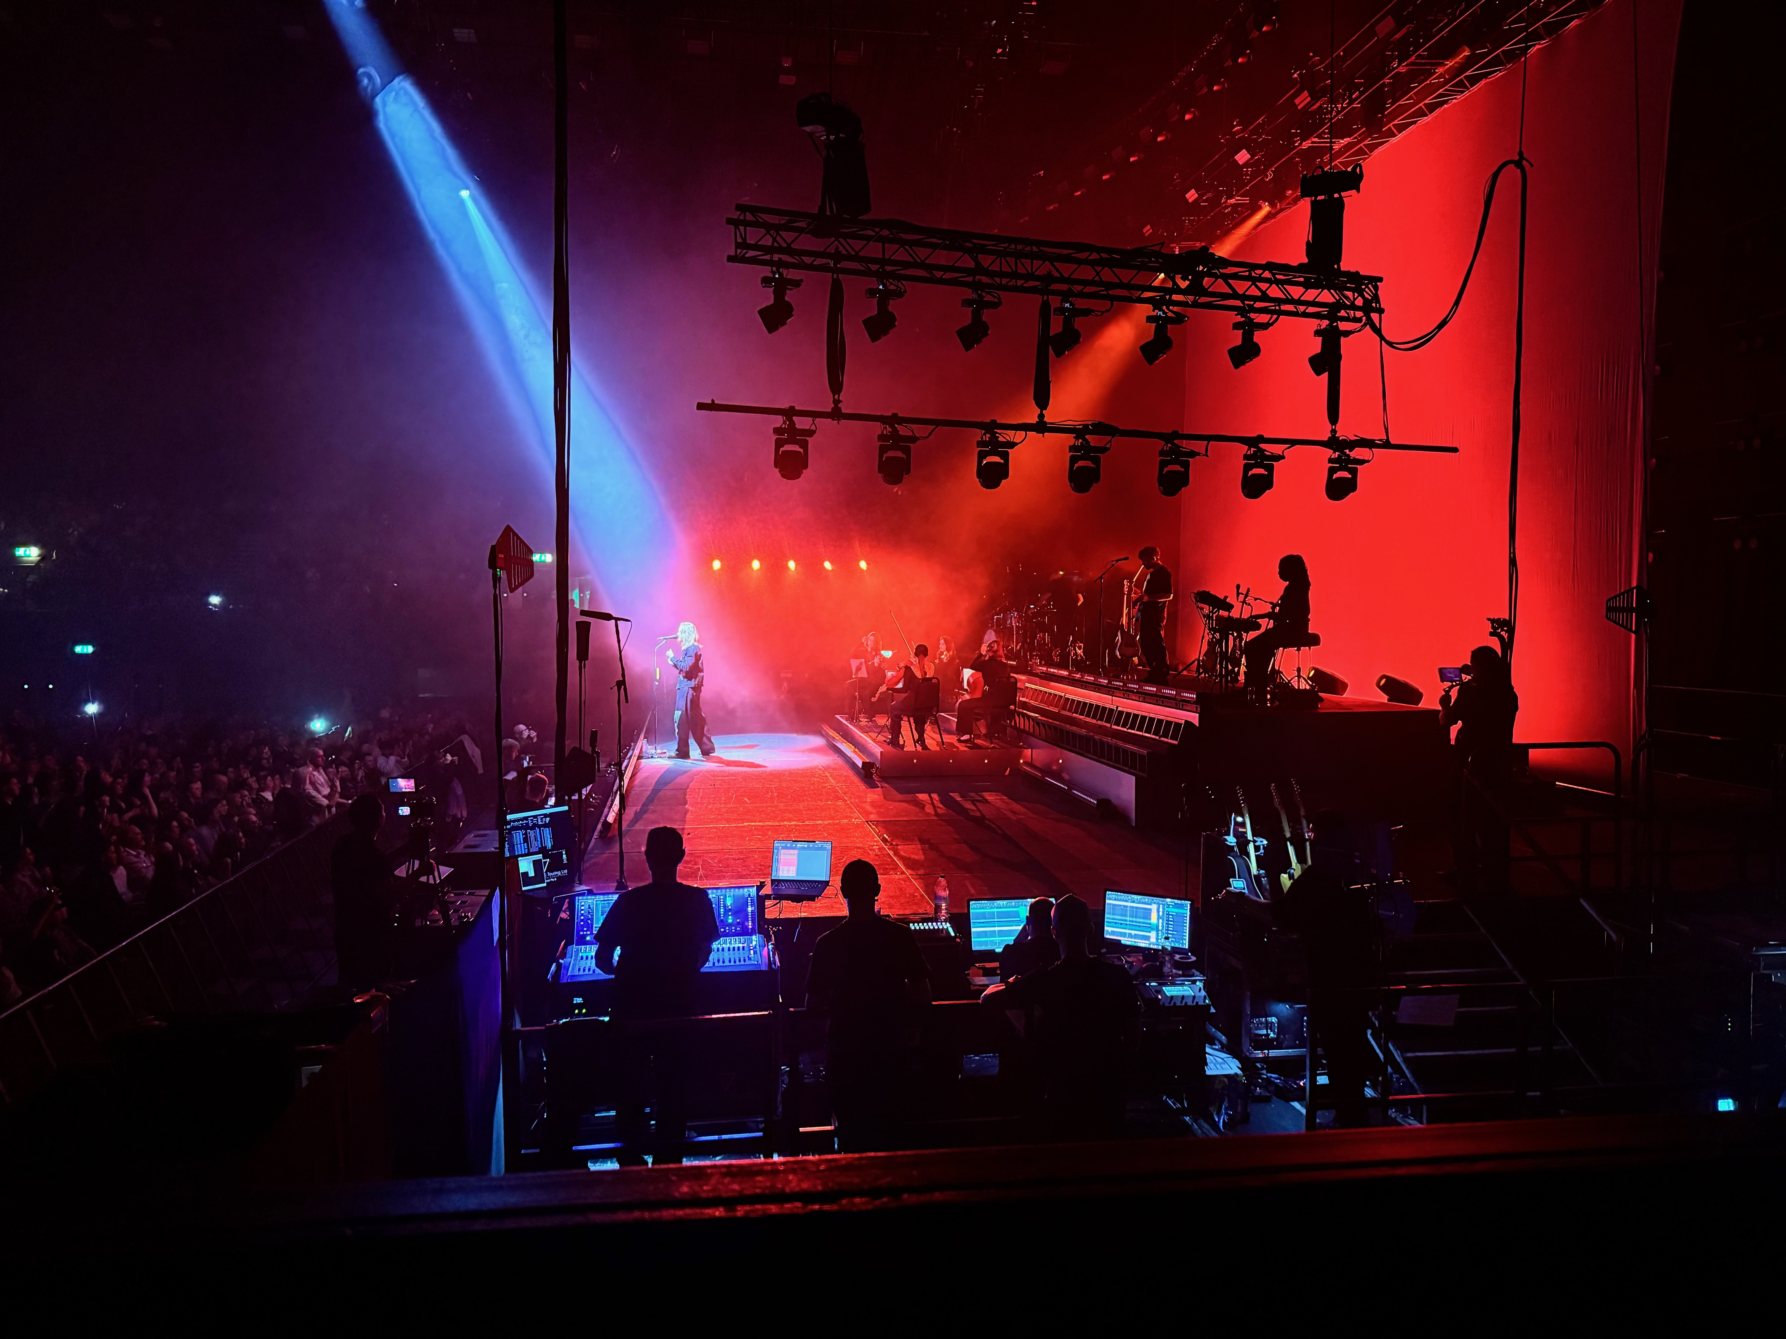 | Hickey’s monitor position at stage left: “As soon as you start passing audio through [Spectera], you can’t help but be impressed by the frequency response and stereo image,” he says.

Small venues, big challenges
In total one Spectera Base Station, four DAD antennas operating on two 8 MHz TV channels, and 18 SEK bodypacks were deployed for the tour — a compact setup that would prove remarkably powerful across wildly different performance spaces. The system was complemented by a range of Sennheiser microphones including SKM 6000 handheld transmitters, MD 421 Kompakts, e 904s, e 935s, and MKH 416s.

Smaller venues present unique challenges that often go unnoticed in purpose-built modern facilities. “There isn’t necessarily a wing at stage left for you to put your monitor desk and all your equipment,” Hickey explains. “You have to poke things around corners, and get under archways and brickwork, and old infrastructure. I love the idea of us having this technology that is so powerful, so reliable, and sounds so good. And it doesn’t necessarily all have to be the big flagship events, which it obviously does incredibly well, too.”

This philosophy — testing Spectera in the trenches of working venues rather than just showcase environments — provided invaluable real-world validation of the system’s capabilities.

Sam Ryder using an evolution e 935 for his vocals (Photo credit: Jenny Hodge) | 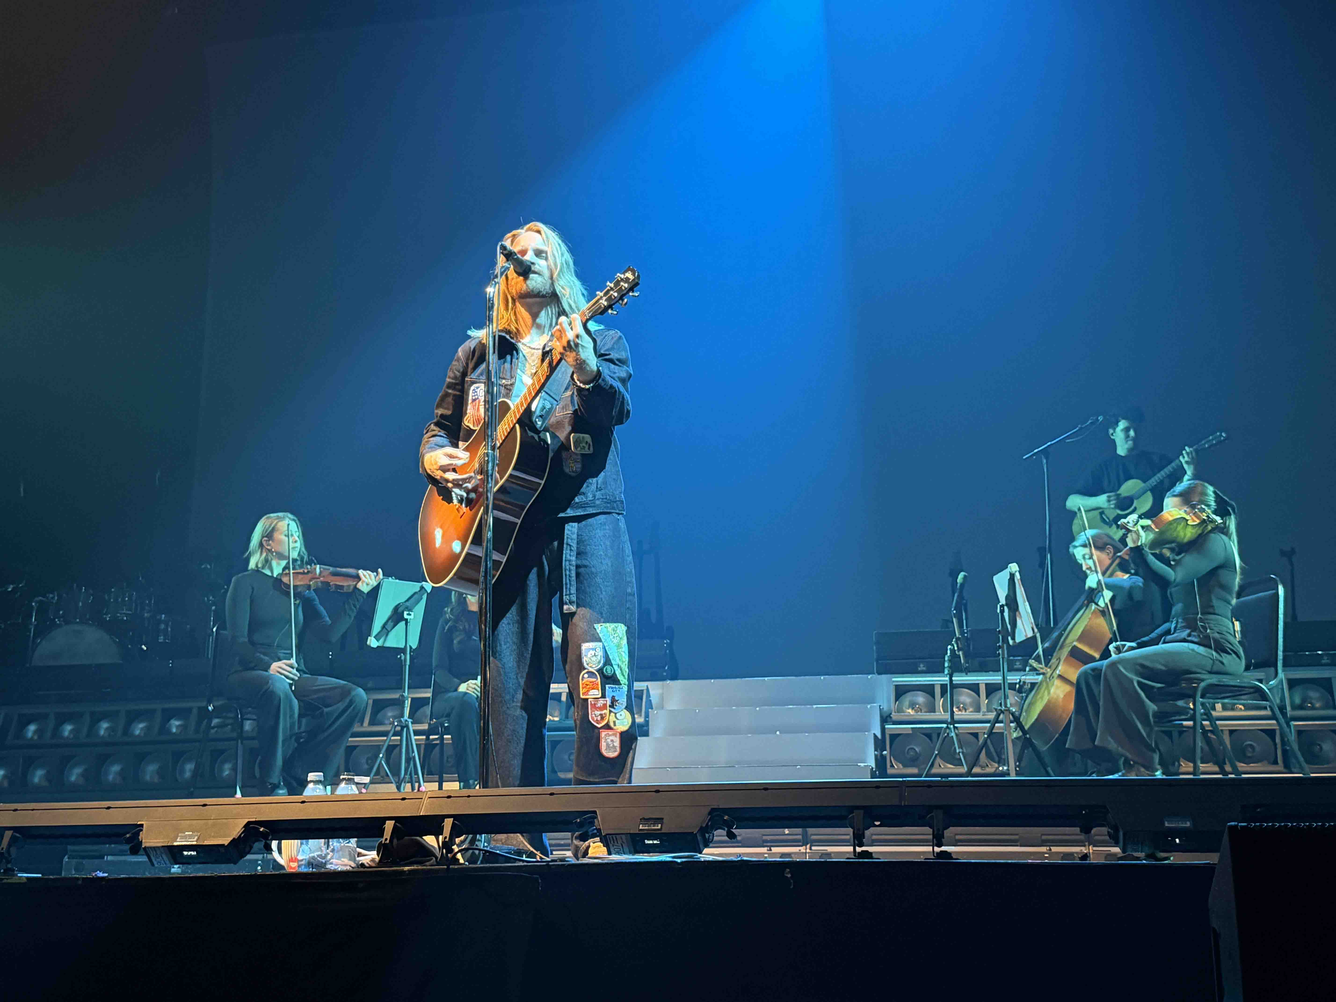

Reaching Wembley Arena
By the time the tour reached Wembley Arena, Hickey was running 13 stereo IEM mixes — with six beltpacks additionally used as transmitters — for nine musicians, one production manager, one playback tech, as well as a management mix, and a guest mix.

“It was a pretty good test of capacity,” Hickey recalls. “I was concerned that we weren’t going to get it all into one unit by the time we got to that many mixes. I was also a bit concerned that we would run out of DSP to be able to do that. But it worked out really well; it was full but there was still room for more. Wembley was a proper deployment.”

The Wembley performance also showcased Spectera’s extraordinary coverage capabilities in ways that genuinely surprised even a veteran engineer like Hickey. “It was the best coverage I've ever heard in my life from anything, anywhere,” he states. “Wembley Arena is a somewhat older building, and the dressing rooms are sort of buried in concrete. I was able to line check the four-piece string section whilst they were in their dressing room, which was maybe 80 metres away. It just blew my mind.”

A dream come true: Sam Ryder playing at Wembley (Photo credit: Jack Robinson)

One ecosystem, infinite possibilities
Spectera’s bidirectional capability — the ability for each SEK bodypack to handle both microphone transmission and in-ear monitor reception simultaneously — proved transformative for the production. “This is a game changer,” says Hickey. “We have one ecosystem that is mics and in-ears. It’s one unit. That’s crazy. And the latency is so usable. The flexibility to be able to go from 0.7 up to 2.7, and to deploy your DSP, your available RF spectrum…It’s just wild.”

This flexibility was put to the test during a particularly meaningful moment at Wembley when Kelvin Pratt, Sam Ryder’s childhood guitar teacher, joined Ryder on stage to play a guitar solo on the song ‘Go Steady’. Pratt’s bodypack was set to transceive, with his guitar signal going to the line system via Dante, then amped through Pratt’s Kemper Profiling Amp, before going back out to the line system, all using Spectera’s ultra-low latency mode.

Hickey admits he was initially concerned about the number of paths that signal had to travel through. “It was not a problem. Not an issue at all,” he confirms. “A complete game-changer. The Dante implementation is fantastic, and it’s a really good addition to the I/O side of it.”

Instant buy-in from musicians
The response from Sam Ryder’s band and musicians was overwhelmingly positive from the first moment they experienced the system. “They were really excited,” Hickey recalls. “Most musicians are geeks at heart, really, and immediately they were quite excited. Just the tactile feel and the look of it says, ‘oh, this is new’. If a product is not delivering a wow factor, or doesn’t offer a noticeable change, nobody can be bothered to think about it. But with Spectera, the sonic character, the delivery, it was instantly noticeable to even the most uninterested person.”

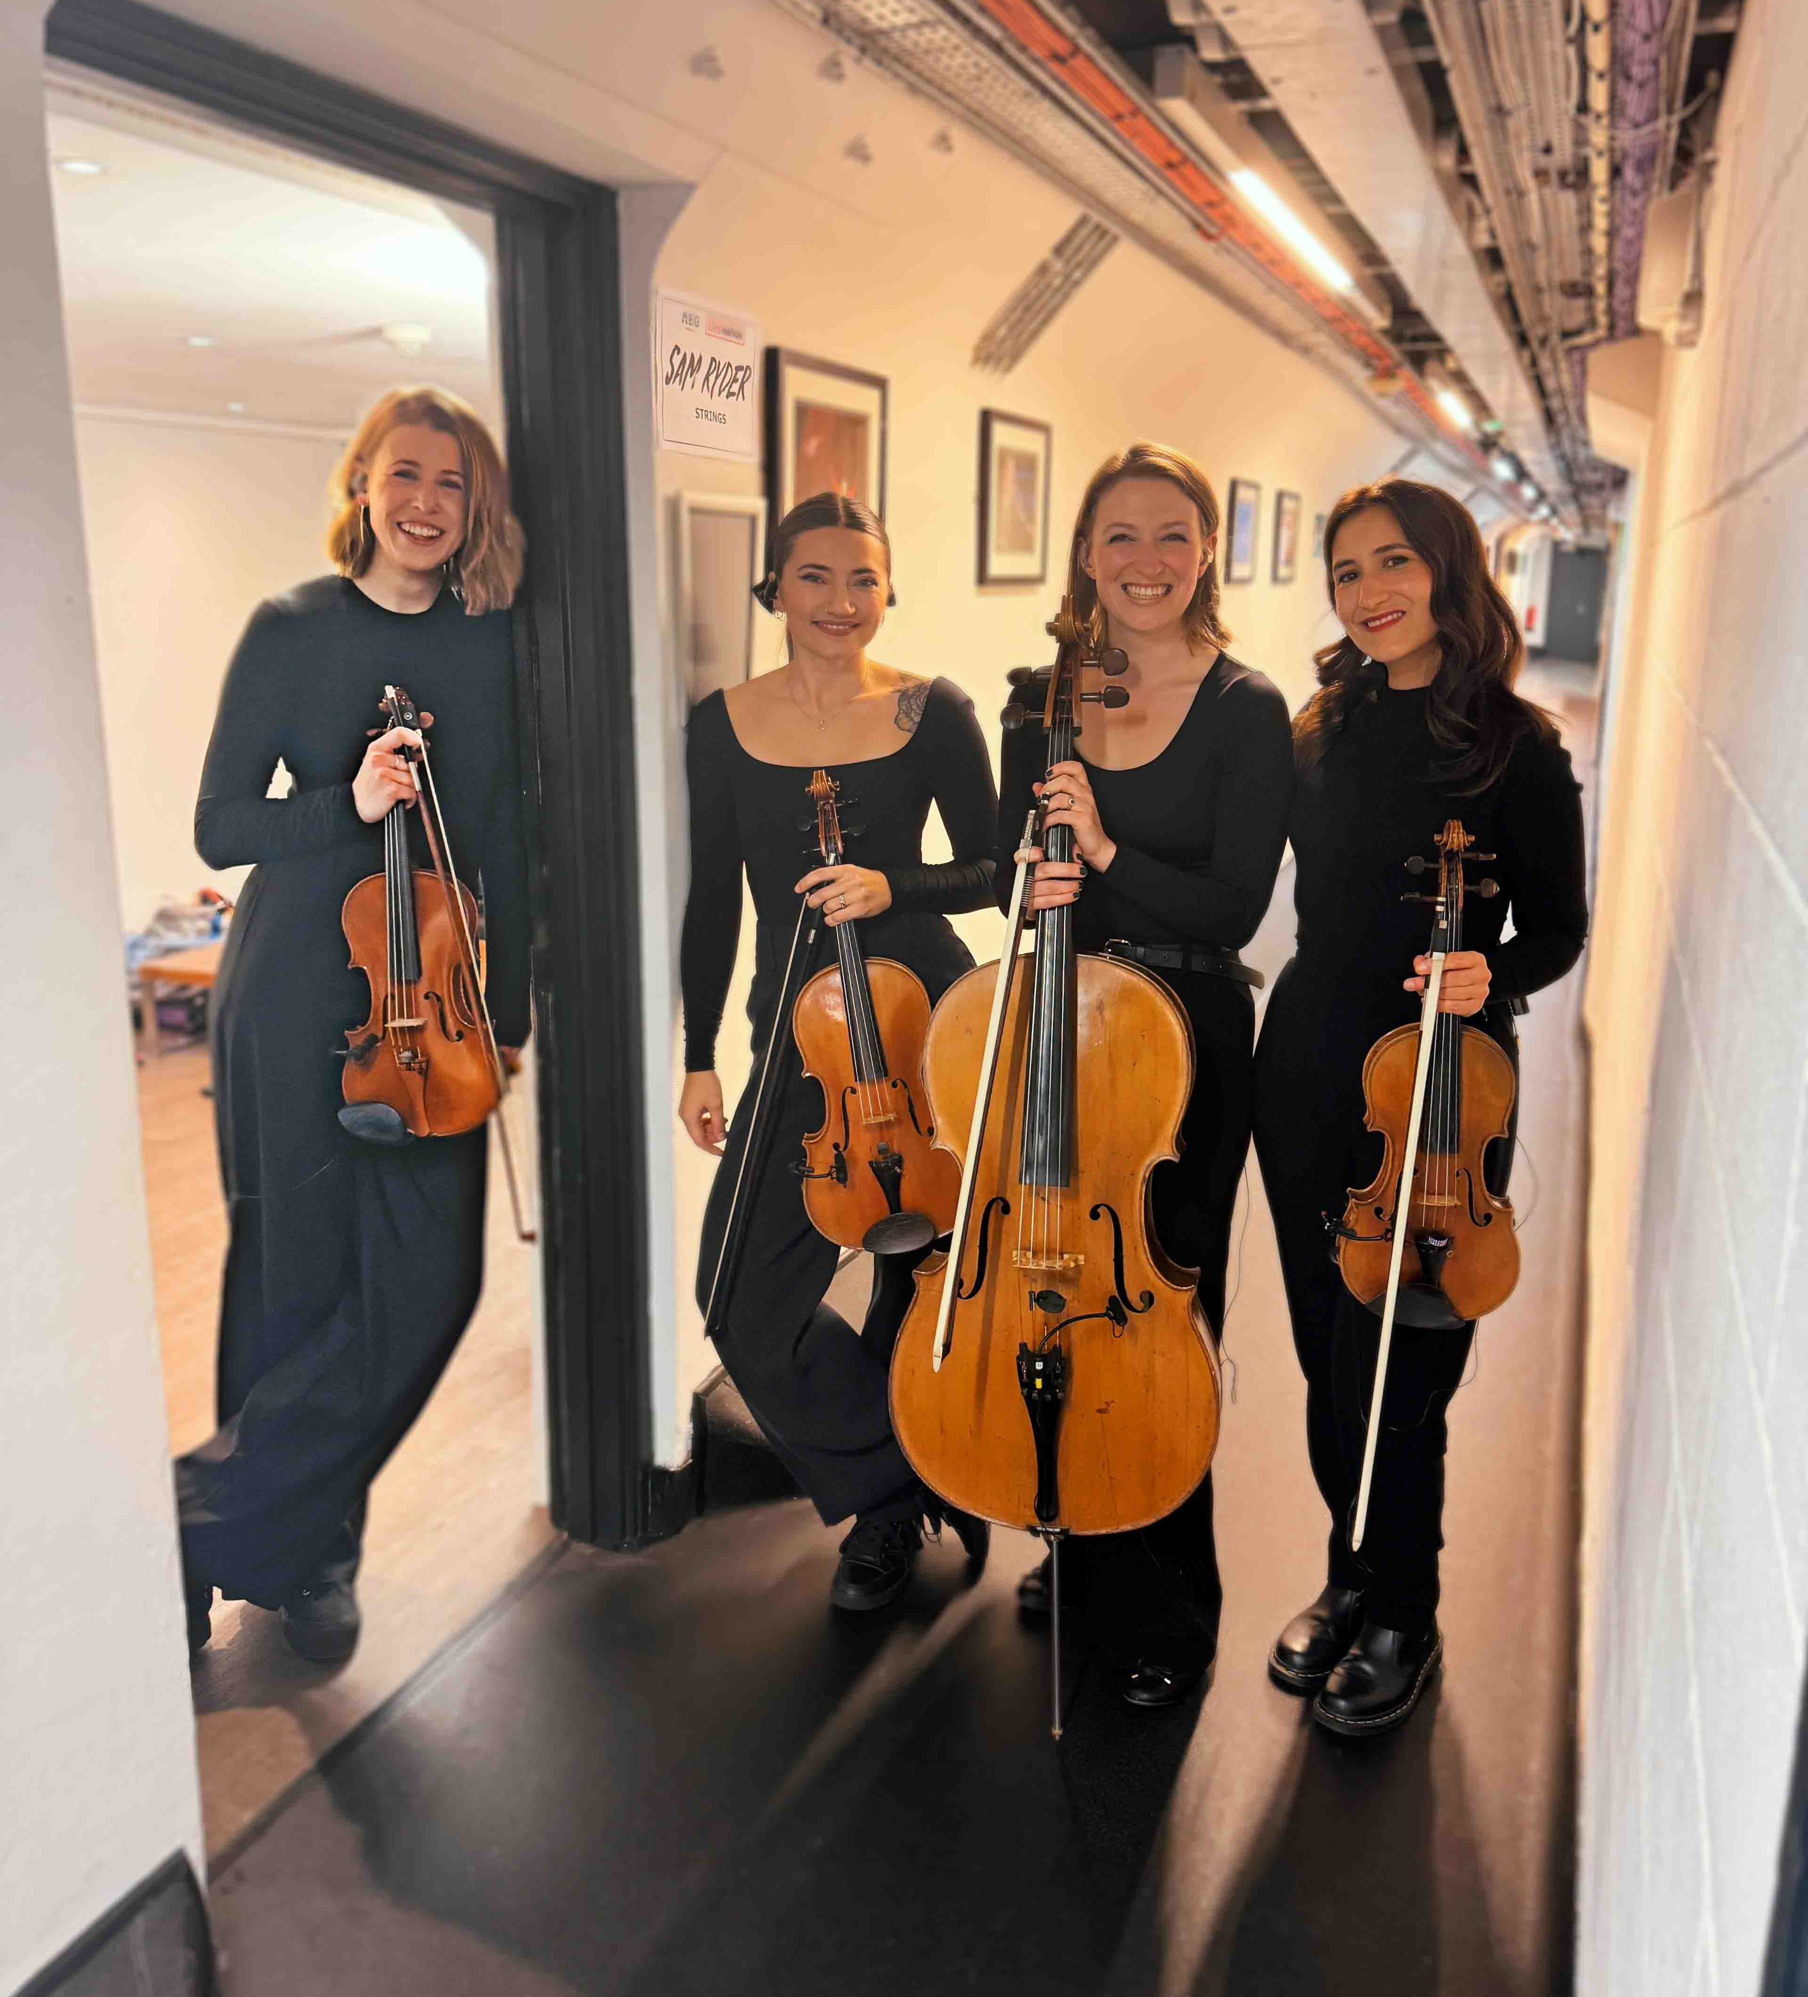 | Sam Ryder’s string section was particularly impressed with Spectera

The string section — players of the most traditional instruments in the ensemble — were particularly impressed. “The string players were on side straight away,” notes Hickey. “One of the comments I got was that they could hear absolutely perfectly. They were a bit terrified about playing at Wembley and what that was gonna be like, but they were all super-positive. Everybody was so happy to the point that the novelty of the technology wore off quite quickly because it was implemented so well.”

Sennheiser’s support throughout the deployment proved instrumental to the tour’s success, demonstrating the value of strong industry partnerships. Hickey credits Peter Craig from Sennheiser’s Relationship Management with facilitating his involvement in the Pioneer Program and getting the system tour-ready.

“Peter’s been great throughout this whole process. It’s that kind of support that makes all the difference when you’re trying something new,” says Hickey.

Hickey also worked extensively with Marcus Blight, Technical Application Engineer at Sennheiser, who provided crucial technical guidance throughout the tour.

“I had questions about RF coverage and implementation, and Marcus was very cool with that,” says Hickey. “He was very quick to respond and give really good, detailed information about it all. He was fully on board. The support from Sennheiser has been fantastic.”

Photo credit: Jack Robinson

A total revolution
Looking back on the tour, Hickey’s enthusiasm for Spectera is unequivocal. “We had absolutely no problem putting it through its paces, working either on a single RF channel or two RF channels. We’ve used it with Dante, we’ve used it with MADI. And it can only get better, based on all the conversations that we’ve had at Decibel Dialogues. There’s so much work going on behind the scenes, and I can’t wait to use it more on everything. It really is, in the most sincere sense of the word, a total revolution.”

www.sam-ryder.com, www.productionandtouring.com
@samhairwolfryder @productionandtouringltd

(Ends)

The high-resolution images accompanying this media release plus additional images can be downloaded here.

About the Sennheiser Brand – 80 Years of Building the Future of Audio
We live and breathe audio. We are driven by the passion to create audio solutions that make a difference. This passion has taken us from the world’s greatest stages to the quietest listening rooms – and made Sennheiser the name behind audio that doesn’t just sound good: It feels true. In 2025, the Sennheiser brand celebrates its 80th anniversary. Since 1945, we have stood for building the future of audio and bringing remarkable sound experiences to our customers. While professional audio solutions such as microphones, meeting solutions, streaming technologies and monitoring systems are part of the business of Sennheiser electronic SE & Co. KG, the business with consumer devices such as headphones, soundbars and speech-enhanced hearables is operated by Sonova Holding AG under the license of Sennheiser.

www.sennheiser.com
www.sennheiser-hearing.com

EMEA Press Contact
Maik Robbe
Maik.Robbe@sennheiser.com
+49 (5130) 600 – 1028

